SOFTWARE REQUIREMENTS SPECIFICATION

**For**

**Student Attendance System**

**Prepared by:-**

*Algotutor Academy*

# Introduction

## Purpose

## The Student Attendance Management System aims to automate and streamline the process of recording and managing student attendance for various courses within an educational institution. This system facilitates efficient tracking of student attendance, course enrollment, and generates comprehensive reports. It integrates a MySQL database to store student and course details, as well as attendance records. Through a Java-based interface, it allows administrators to add/edit student and course information, mark attendance, and generate attendance reports. The SRS outlines the functional and non-functional requirements, ensuring a user-friendly, scalable, and secure system for improved attendance monitoring.

* + - Entire document should be justified.
    - Convention for Main title

Font face: Times New Roman Font style: Bold

Font Size: 14

* + - Convention for Sub title

Font face: Times New Roman Font style: Bold

Font Size: 12

* + - Convention for body

Font face: Times New Roman Font Size: 12

## Scope of Development Project

The Student Attendance Management System project encompasses the development of a comprehensive solution for efficiently monitoring and managing student attendance within educational institutions. It involves the creation of a Java-based application integrated with a MySQL database, enabling functionalities such as attendance recording, course and student management, user authentication, and report generation. The system will allow administrators to add, modify, or remove course details, student information, and attendance records, ensuring a user-friendly interface for seamless interaction. Non-functional aspects like scalability, security, and performance optimization will be key focuses, ensuring the system's reliability, responsiveness, and data integrity while maintaining compliance with institution policies.

However, the project excludes functionalities like financial transactions, external system integrations beyond attendance management, and intricate features like payment processing. Time and resource constraints necessitate a focused development approach primarily centered on attendance tracking, user management, and report generation. The system aims to offer a robust and secure platform for handling attendance-related operations within the educational setting, prioritizing efficiency, ease of use, and compliance with regulatory guideline.

## Definitions, Acronyms and Abbreviations

JAVA -> platform independence SQL-> Structured query Language ER-> Entity Relationship

UML -> Unified Modeling Language

IDE-> Integrated Development Environment SRS-> Software Requirement Specification

## References

* + - Books

 Software Requirements and Specifications: A Lexicon of Practice, Principles and Prejudices (ACM Press) by Michael Jackson

Software Requirements (Microsoft) Second EditionBy Karl E. Wiegers

Software Engineering: A Practitioner’s Approach Fifth Edition By Roger S. Pressman

* + - Websites

[**http://www.slideshare.net/**](http://www.slideshare.net/)

[**http://ebookily.net/doc/srs-library-management-system**](http://ebookily.net/doc/srs-library-management-system)

# Overall Descriptions

## Product Perspective

Use Case Diagram of Student Attendance System

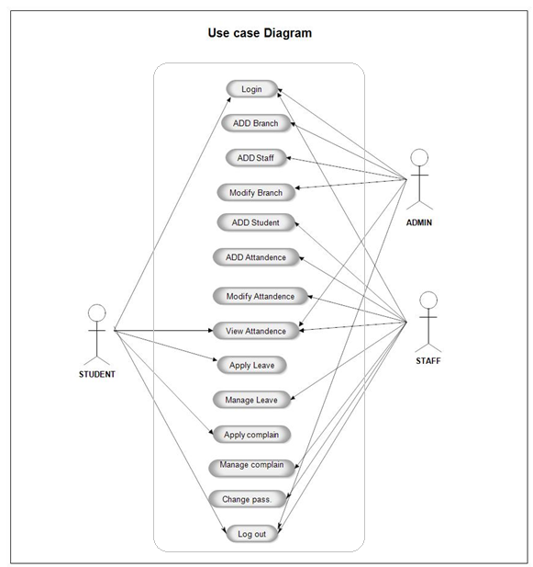

## Product Function

Entity Relationship Diagram of Library Management System

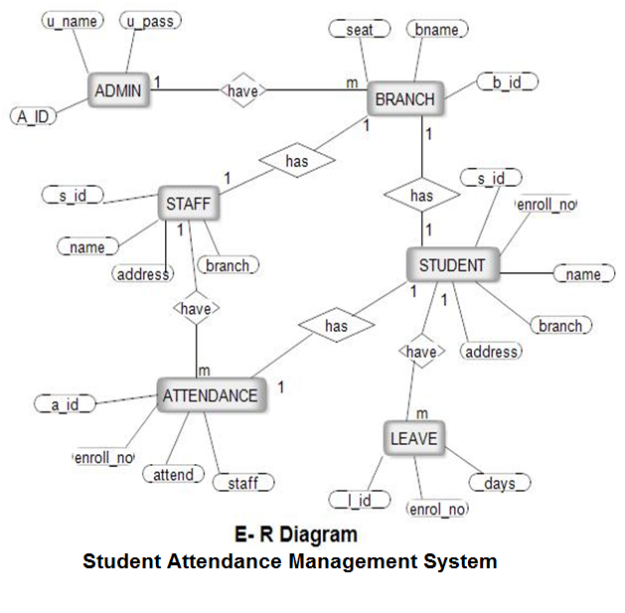

Entity-Relationship (ER) diagrams serve as visual representations of database structures, comprising entities, attributes, relationships, and their connections. Entities are depicted as boxes representing real-world elements such as Students, Courses, and Attendance. Attributes within entities, like Student ID or Course Name, describe specific characteristics. Relationships, illustrated by lines between entities, showcase associations like a Student enrolling in Courses or Attendance Records linked to Students and Courses. Cardinality annotations signify the quantity of instances involved in these relationships, like "one-to-many" or "many-to-many." Primary keys uniquely identify each entity instance, while foreign keys establish connections between tables. ER diagrams assist in database normalization by organizing data, minimizing redundancy, and ensuring data integrity through proper structuring and relationship representation.

## User Classes and Characteristics

The system provides different types of services based on the type of users [Student/Faculty]. The Faculty will be acting as the controller and he will have all the privileges of an administrator. The member student of the institution who will be accessing the Summary online.

The features that are available to the Faculty are:-

* + - A Faculty can issue a book to the member.
    - Can view the Summary of Attendance
    - Can look the leave taken by students
    - Edit the information of existing Attendance
    - Can check the report of the Attendance
    - Can access all the accounts of the students

The features that are available to the Students are:-

* + - Can view the Attendance marked for the different subjects.
    - Can view the Overall Summary of the Attendance of Students
    - Can own an account in the System.

## Operating Environment

The product will be operating in windows environment. The Library Management System is a website and shall operate in all famous browsers, for a model we are taking Microsoft Internet Explorer,Google Chrome,and Mozilla Firefox.Also it will be compatible with the IE 6.0. Most of the features will be compatible with the Mozilla Firefox & Opera 7.0 or higher version. The only requirement to use this online product would be the internet connection.

The hardware configuration include Hard Disk: 40 GB, Monitor: 15” Color monitor, Keyboard: 122 keys. The basic input devices required are keyboard, mouse and output devices are monitor, printer etc.

## Assumptions and Dependencies

The assumptions are:-

* + - The coding should be error free
    - The system should be user-friendly so that it is easy to use for the users
    - The information of all users, must be stored in a database that is accessible by the website
    - The system should have more storage capacity and provide fast access to the database
    - The system should provide search facility and support quick transactions
    - The Attendance System is running 24 hours a day
    - Users may access from any computer that has Internet browsing capabilities and a Internet connection.
    - Users must have their correct usernames and passwords to enter into their online accounts and do actions

The dependencies are:-

* + - The specific hardware and software due to which the product will be run
    - On the basis of listing requirements and specification the project will be developed and run
    - The end users (admin) should have proper understanding of the product
    - The system should have the general report stored
    - The information of all the users must be stored in a database that is accessible by the Library System
    - Any update regarding the book from the library is to be recorded to the database and the data entered should be correct

## Requirement

Software Configuration:-

This software package is developed using java as front end which is supported by sun micro system. Microsoft SQL Server as the back end to store the database.

Operating System: Windows NT, windows 98, Windows XP Language: Java Runtime Environment, Net beans 7.0.1 (front end) Database: MS SQL Server (back end)

Hardware Configuration:- Processor: Pentium(R)Dual-core CPU Hard Disk: 40GB

RAM: 256 MB or more

## Data Requirement

The inputs consist of the query to the database and the output consists of the solutions for the query. The output also includes the user receiving the details of their accounts. In this project the inputs will be the queries as fired by the users like create an account. Now the output will be visible when the user requests the server to get details of their account in the form of time, date and which books are currently in the account.

# External Interface Requirement

## GUI

The software provides good graphical interface for the user and the administrator can operate on the system, performing the required task such as create, update, viewing the details of the book.

* + - It allows user to view quick reports like Attendance in between particular time.
    - It provides stock verification and search facility based on different criteria.
    - The user interface must be customizable by the administrator
    - All the modules provided with the software must fit into this graphical user interface and accomplish to the standard defined
    - The design should be simple and all the different interfaces should follow a standard

template

* + - The user interface should be able to interact with the user management module and a part of the interface must be dedicated to the login/logout module

Login Interface:-

In case the user is not yet registered, he can enter the details and register to create his account. Once his account is created he can ‘Login’ which asks the user to type his username and password. If the user entered either his username or password incorrectly then an error message appears.

Attendance View:-

Attendance view shows the attendance of the particular student

Faculty Control Panel:-

This control panel will allow faculty to add/remove users; add, edit, or remove attendance for particular hour. And manage lending options.

# System Features

The users of the system should be provided the surety that their account is secure. This is possible by providing:-

* User authentication and validation of members using their unique member ID
* Proper monitoring by the administrator which includes updating attendance status, the limit provided by the institution policy.
* Proper accountability which includes not allowing a member to see other member’s account. Only administrator will see and manage all member accounts

# Other Non-functional Requirements

## Performance Requirement

The proposed system that we are going to develop will be used as the Chief performance system within the different campuses of the university which interacts with the university staff and students. Therefore, it is expected that the database would perform functionally all the requirements that are specified by the university.

* + - The performance of the system should be fast and accurate
    - Student Management System shall handle expected and non-expected errors in ways that prevent loss in information and long downtime period. Thus it should have inbuilt error testing to identify invalid username/password
    - The system should be able to handle large amount of data. Thus it should accommodate high number of books and users without any fault

## Safety Requirement

The database may get crashed at any certain time due to virus or operating system failure. Therefore, it is required to take the database backup so that the database is not lost. Proper UPS/inverter facility should be there in case of power supply failure.

## Security Requirement

* + - System will use secured database
    - Normal users can just read information but they cannot edit or modify anything except their personal and some other information.
    - System will have different types of users and every user has access constraints
    - Proper user authentication should be provided
    - No one should be able to hack users’ password
    - There should be separate accounts for admin and members such that no member can access the database and only admin has the rights to update the database.

## Requirement attributes

* + - There may be multiple admins creating the project, all of them will have the right to create changes to the system. But the members or other users cannot do changes
    - The project should be open source
    - The Quality of the database is maintained in such a way so that it can be very user friendly to all the users of the database
    - The user be able to easily download and install the system

## Business Rules

A business rule is anything that captures and implements business policies and practices. A rule can enforce business policy, make a decision, or infer new data from existing data.This includes the rules and regulations that the System users should abide by. This includes the cost of the project and the discount offers provided. The users should avoid illegal rules and protocols. Neither admin nor member should cross the rules and regulations.

## User Requirement

The users of the system are Student and Faculties of the university who act as administrator to maintain the system. The Students are assumed to have basic knowledge of the computers and internet browsing. The administrators of the system should have more knowledge of the internals of the system and is able to rectify the small problems that may arise due to disk crashes, power failures and other catastrophes to maintain the system. The proper user interface, user manual, online help and the guide to install and maintain the system must be sufficient to educate the users on how to use the system without any problems.

The admin provides certain facilities to the users in the form of:-

* + - Backup and Recovery
    - Forgot Password
    - Data migration i.e. whenever user registers for the first time then the data is stored in the server
    - Data replication i.e. if the data is lost in one branch, it is still stored with the server
    - Auto Recovery i.e. frequently auto saving the information
    - Maintaining files i.e. File Organization
    - The server must be maintained regularly and it has to be updated from time to time

# Other Requirements

## Data and Category Requirement

There are different categories of users namely teaching staff, Faculties, students etc. Depending upon the category of user the access rights are decided.It means if the user is an administrator then he can be able to modify the data,delete, append etc. All other users except the Faculties only have the rights to retrieve the information about database. Similarly there will be different categories of books available. According to the categories of books their relevant data should be displayed. The categories and the data related to each category should be coded in the particular format.

## Appendix

F: Faculties, Abbreviation, Acronym, Assumptions; B: Books, Business rules; C: Class, Client, Conventions; D: Data requirement, Dependencies; G: GUI; K: Key; M: Member; N: Non-functional Requirement; O: Operating environment; P: Performance,Perspective,Purpose; R: Requirement, Requirement attributes; S: Safety, Scope, Security, System features,Students; U: User, User class and characteristics, User requirement;

## Glossary

The following are the list of conventions and acronyms used in this document and the project as well:

* + - Administrator: A login id representing a user with user administration privileges to the software
    - User: A general login id assigned to most users
    - Client: Intended users for the software
    - SQL: Structured Query Language; used to retrieve information from a database
    - SQL Server: A server used to store data in an organized format
    - Layer: Represents a section of the project
    - User Interface Layer: The section of the assignment referring to what the user interacts with directly
    - Application Logic Layer: The section of the assignment referring to the Web Server. This is where all computations are completed
    - Data Storage Layer: The section of the assignment referring to where all data is recorded
    - Use Case: A broad level diagram of the project showing a basic overview
    - Class diagram: It is a type of static structure diagram that describes the structure of a system by showing the system’s cases, their attributes, and the relationships between the classes
    - Interface: Something used to communicate across different mediums
    - Unique Key: Used to differentiate entries in a database

## Class Diagram

A class is an abstract, user-defined description of a type of data. It identifies the attributes of the data and the operations that can be performed on instances (i.e. objects) of the data. A class of data has a name, a set of attributes that describes its characteristics, and a set of operations that can be performed on the objects of that class. The classes’ structure and their relationships to each other frozen in time represent the static model. In this project there are certain main classes

which are related to other classes required for their working. There are different kinds of relationships between the classes as shown in the diagram like normal association, aggregation, and generalization. The relationships are depicted using a role name and multiplicities. Here ‘Student’, ‘Faculty’ and ‘Courses’ are the most important classes which are related to other classes.

